**Genesis Space White Paper**

A virtual world built on blockchain

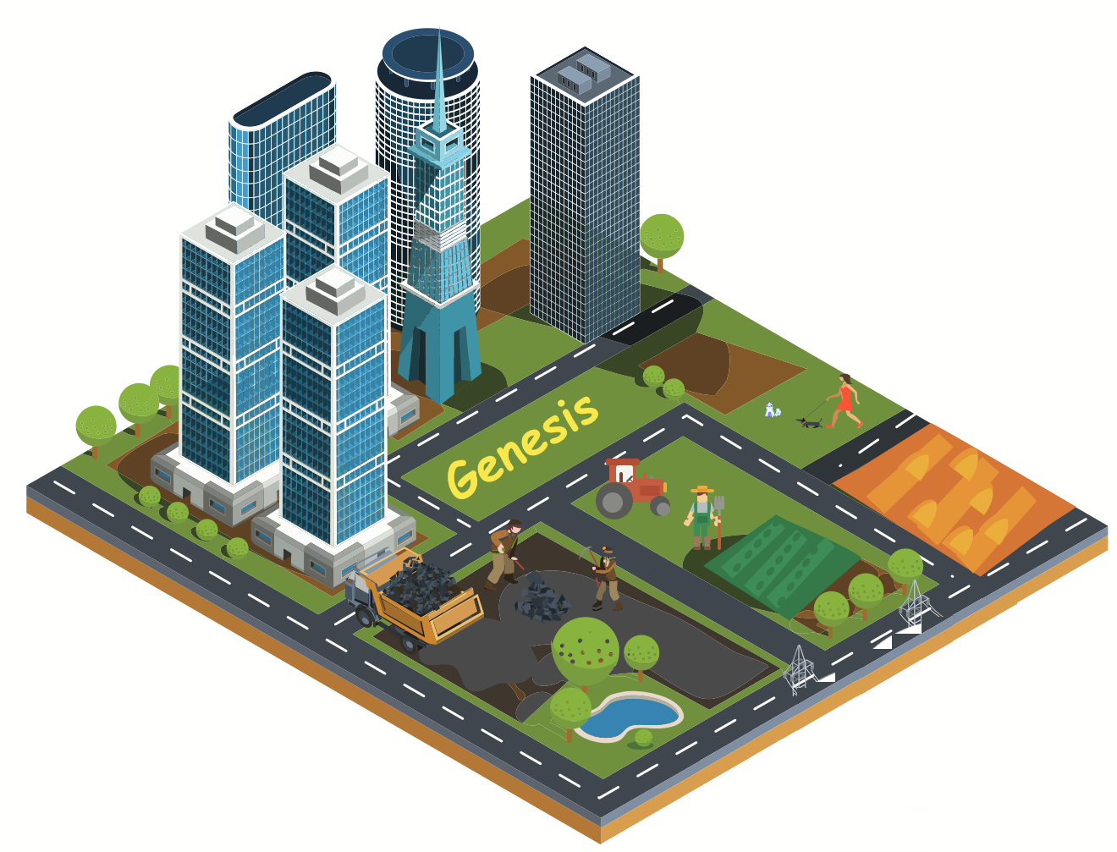

12/31/2017

Genesis Inc. (TBD)

Address: 91 E Brokaw Rd, San Jose, CA 95112

Tel: 5167770588 Email: mymatrixspace@gmail.com

**Executive Summary**

In 1996, in response to the passing into law of the Telecommunications Act in the United States, John Perry Barlow published an article “*A Declaration of the Independence of Cyberspace”.* In this article, he pictured a virtual world “*consists of transactions, relationships, and thought itself, arrayed like a standing wave in the web of our communications*”. In this virtual world, anyone can express their own beliefs without being discriminated.

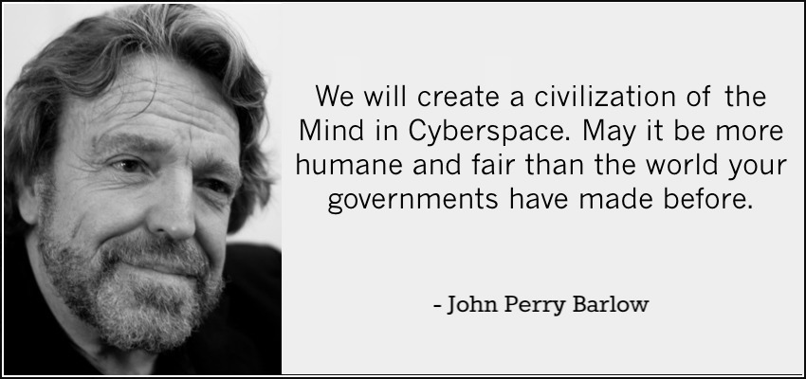

However, his claims were not feasible technologically 20 years ago. Today, we bring up his goal again. With the rapid development of blockchain technology, a fully decentralized virtual world with democratic governance becomes possible.

Genesis is a decentralized community based on blockchain technology. It provides users with a highly autonomous virtual world in which users can create, experience applications and maintain the order of the world themselves.

Different from other online communities, Genesis has no central authority. At the initial stage, only a set of rules would be predefined. The virtual world’s evolution will depend on users’ voting. For big issues like changing rules and arbitrations, the option with the majority voting will be implemented. In this way, we can create a self-regulating and self-improving community.

This document introduces the virtual world’s governance philosophy, technique foundations, and the economic model.

Contents

**1.** **Introduction** 5

**1.1** **Rational** 5

**1.2** **Governance** 5

**1.2.1** **Users** 6

**1.2.2** **Gencoin** 6

**1.2.3** **Markets** 7

**1.2.4** **Constitutes** 7

**1.2.5** **Voting** 7

**2.** **Genesis Ecosystem** 8

**2.1** **Business Prospect** 8

**2.2** **Genesis Community** 8

**2.2.1** **Incentive Mechanism** 8

**2.2.2** **User-Oriented Interface** 8

**2.2.3** **Gencoin in the community** 8

**2.3** **Application Scenarios** 9

**2.3.1** **Data Processing** 9

**2.3.2** **Social Media** 9

**2.3.3** **Arbitration Mechanism** 10

**2.3.4** **Game** 10

**3.** **Genesis Blockchain Technology** 11

**3.1** **Proof of Comprehension** 11

**3.2** **Side Chain Technology** 13

**3.2.1** **Independent Contracts** 14

**3.2.2** **Indexing** 14

**3.2.3** **File Storage** 14

**3.2.4** **Dapp Store** 14

**3.2.5** **Node Floating Mechanism** 14

**4.** **Genesis Token Model** 16

**4.1** **Definition of Tokens** 16

**4.2** **Usage of Tokens** 16

**4.3** **Token Sales** 16

**5.** **Foundation** 18

**5.1** **Governance Principles** 18

**5.2** **Foundation Organization** 18

**5.3** **Advisory Committee** 18

**5.4** **Budget Planning** 19

**5.4.1** **Funding Resource** 19

**5.4.2** **Funding Allocation** 19

**5.5** **Road Map** 19

**6.** **Team Members and Advisors** 21

**6.1** **Team Members** 21

**6.2** **Advisors** 23

**7.** **Originality Statement** 24

**8.** **Disclaimer** 25

**8.1** **Risk Warning** 25

**8.1.1** **Risks in respect of the Ethereum Protocol** 26

**8.1.2** **Risk in respect of delivery** 26

**8.1.3** **Risks in respect of security failure** 26

**8.1.4** **Risks in respect of regulatory impacts** 26

1. **Introduction**

## **Rational**

Social Platforms gather people from all over the world, provide a space for creating and sharing, help people play together and make the world smaller. These platforms are quite successful as they act as a mini-society with efficiency and stability. Nevertheless, when people register and use these property platforms, the centralized platforms inevitably collect much clients’ personal information and form an absolute power both on the user side and the server provider side. Users and content can be created, deleted, access and blocked for any possible reasons. Actually account owners only have the right to use but not the right to own.

Blockchain technology provides a solution regarding the ownership issue. Genesis is designed as a decentralized virtual world for users to fully control their personal information, original content and existent properties. The infrastructure allows Genesis users to build countries, do transaction, create laws, sell lands, play games and develop even more useful applications based on the Genesis community.

Genesis Space is a virtual world based on blockchain technology which offers user the real ownership of themselves.

## **Governance**

Genesis is a decentralized community based on blockchain technology. The core concept for Genesis’ governance is self-regulation.

Different nodes (users) in Genesis:

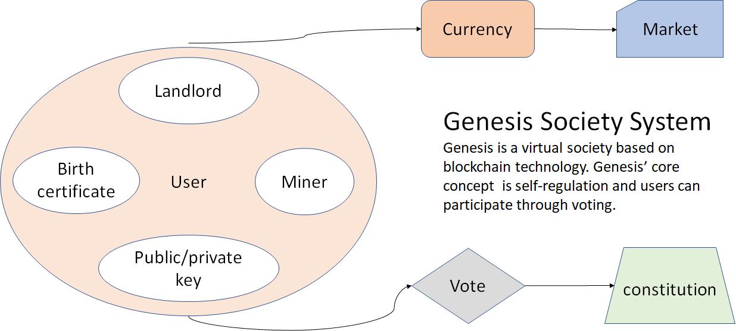

Genesis Society System

### **Users**

Users are key to Genesis’ ecosystem. Genesis consists of a main chain and many side chains. All these chains share the same user system. Users in Genesis can be divided into normal users, miners (those who maintain blockchain) and landholders (those who maintain storage).

Key features for Users:

* Users need to generate their own public / private key.
* Users need to set up a private string for identity verification when they register.
* Every user has voting rights.

Different roles for Users:

* Miner: Miner nodes provide the computing power for executing consensus mechanism.
* Landholder: Landholder nodes provide the decentralized storage services for all other nodes.
* Normal Users: Normal user nodes can purchase applications from markets, participate in voting etc.

### **Gencoin**

Gencoin is the fuel for the whole Genesis ecosystem and it is mainly produced by mining. The mining algorithm of Genesis is similar to Ethereum which uses a sufficiently broad range of computation to remove the benefit of specialized hardware. This will make Genesis more sustainable and encourage more nodes to participate in mining.

Ways to gain Gencoin:

* All nodes: Users’ data are analysed by applications to get insights.
* Landholder: Providing hashing power for cloud storage services.
* Miner: Providing hashing power for maintaining blockchain.
* All nodes: Participate in voting sponsored by others.
* All nodes: create useful content and applications.

Ways to spend Gencoin:

* Getting users’ permissions to access their personal data.
* Initiate a voting

Basically, actions that need computing power consume users’ Gencoins. This is to prevent DDoS attack.

### **Markets**

Genesis market is the place for users to purchase Dapps and it’s also called app store. In app store, normal users can find applications to fulfil their needs in the virtual world. For developers, they can publish applications and get the full control of them.

### **Constitutes**

Citizens of Genesis can establish an agreement among users who sign it, referred to as “constitution” or “laws” if it is just an agreement among a small group of users. The content of constitution defines obligations among the users which cannot be entirely enforced by codes.

### **Voting**

Every user in Genesis have voting rights. Voting is the core function for users to participate in the democratic governance process. In situations where codes cannot handle, like a software bug, Genesis relies on user voting to make decisions.

Any node can propose a motion for voting and broadcast to the whole network. A simple motion to vote includes the following contents:

* Motion description
* Content of the motion (smart contract)
* Reward amount
* Duration of voting
* Votes need to pass

All transactions must record the hash of the constitution as part of the signature. In the case where there is a need to update the constitution, one user can attach the proposed updated version to the transaction and broadcast. If ⅔ of the population include this transaction in their POW, then the updated version will be executed immediately. All constitutions contain a paragraph of suicide codes. If any client node is detected as a previous version of the constitution, the code will execute and shutdown the client.

Voting is a type of transactions in Genesis. The person who brings up a motion to vote must attach reward payment to voters. These motions are not limited to protocol updates. Votes can also be used to arbitrate disputes among users. Voting is conducted through the wallet client.

1. **Genesis Ecosystem**

## **Business Prospect**

Genesis is designed to be a self-evolving virtual ecosystem which promotes users and developers to keep contributing contents and functionalities to the system. The Genesis public chain with a user-oriented interface offers a better user experience and an even stronger network where both users and developers can conveniently have access to the system and focus on their desired Dapps or core business logic.

## **Genesis Community**

### **Incentive Mechanism**

The Proof of Comprehension mechanism (POC)，Genesis’ version of Proof of Work, brings direct economic benefits to Genesis users as an economic incentive of the early Genesis community. Users of Genesis can mine directly through PC, MAC and mobile phone with the lower mining threshold that attracts more users to join the community in the early stage.

### **User-Oriented Interface**

Genesis will focus on improving the user experience regarding problems such as huge wallet files, high mining thresholds, complex settings and single function in most blockchain projects. The simplified user-friendly Genesis’ client can run cross-platforms and relatively lower the entrance of the virtual blockchain world and allow more people to join Genesis Community.

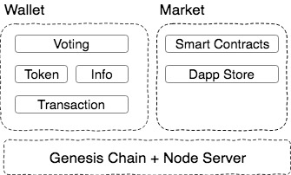The following is the Genesis client's interface:

User-Oriented Interface

### **Gencoin in the community**

Gencoin is an asset equivalent in the Genesis Community and the fuel for the Genesis Ecosystem. Gencoin can be used to establish a country, create or download an application, run a smart contract, play games and all other possible activities in the community or the virtual society. Users and servers in the Genesis can easily access to the system and the standardized currency system simplified all functionalities in Genesis.

## **Application Scenarios**

### **Data Processing**

Huge amount of data generated worldwide can be processed by Genesis. For example, meteorological research scientists can download a data processing application from Genesis' application store and then authorize the application to retrieve data that needs to be processed. Normally, it can take days or even weeks to process the data even on a supercomputer, but in Genesis the process can be finished in a very short time with the great hashing power of thousands of nodes.

Genesis will develop Kaggle for external data source docking and promote to use Genesis' hashing power for data model training. The modularized POC will also be applied in other chain by SaaS。

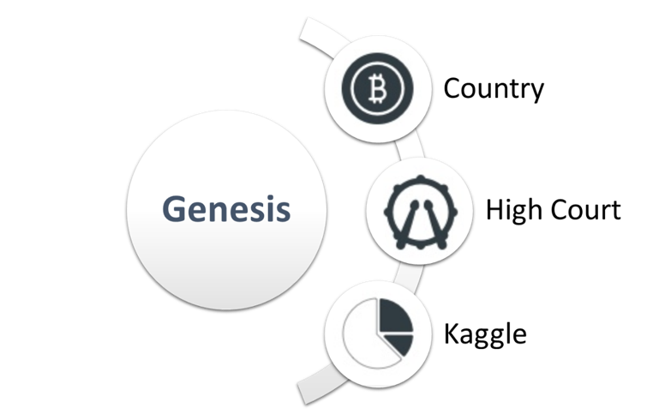

Genesis Dapps Market

### **Social Media**

In the centralized social platform, user data is managed by the server of a certain organization. User’s right cannot be guaranteed for their personal information and message might be blocked and deleted for any potential reasons. In Genesis, user information exists directly within the blockchain and is not controlled by any entity. The user's behaviour is limited only by the rules of conduct decided by users. Under this mechanism, the programmer can develop a decentralized Twitter, Facebook, WeChat and any other social platforms. The concept of decentralized social platform enabling users to fully control their accounts and contents has a great appeal to users.

Genesis’ social media strategy turned Genesis’ wallet into a cross-platform tool that allowed users to log in to their existing accounts and open the channel of blockchain and traditional Internet.

### **Arbitration Mechanism**

Disputes in trading and contract signing happen almost everywhere. In a centralized system, costly and inefficient customer service is often responsible for arbitrating. In Genesis, conflicts can be solved by arbitration applications.

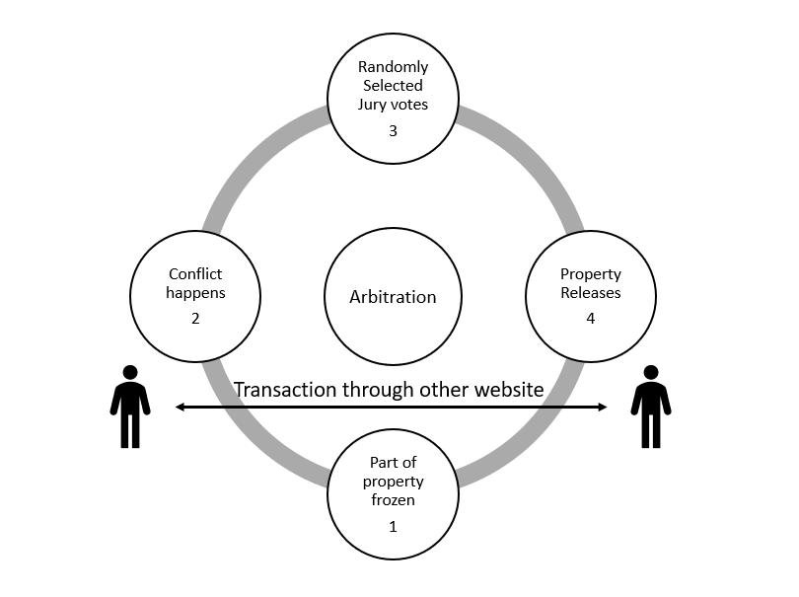Genesis uses a jury model to arbitrate user disputes. Genesis’ arbitration module is embedded in the Genesis wallet and then linked to other websites through the user's system. For example, two unknown peers can login to Craigslist with the Genesis private key at the same time and submit a transaction request. Part of the property on both sides will be frozen in the system to guarantee the safety of transaction. When disputes happen, both parties may apply for arbitration within Genesis and attach the arbitration fee. The system will randomly select 12 jury users for arbitration and the results will be automatically reflected in users’ purses.

Arbitration Model

### **Game**

Once the decentralized game developed, it exists forever. The social attribution of Genesis can help Genesis develop decentralized cats, dogs, the rich and other SIM-like role-playing games. Besides, residents of Genesis can build countries, cities, sell real estate and achieve other social scenarios in side chains.

1. **Genesis Blockchain Technology**

## **Proof of Comprehension**

Proof of Work (PoW) and Proof of Stake (PoS) are some main scripting algorithms that we see at work today in Bitcoin and Ethereum protocols. However, the solution produced by the traditional POW/POS algorithms is meaningless as its quality is only determined by the length of a sequence reflecting the robustness of the blockchain.

It is well-known that artificial intelligence with deep learning has made breakthrough progress in recent years, including speech recognition and image recognition. Training deep learning models requires significant computation, and the accumulation of computing power plays a decisive role in the effect of deep learning model. However, as high-performance computing devices like GPUs are expensive and often in short supply on the market, insufficient computation power has become one of the bottlenecks for academics and industry to build better and deeper learning systems.

Genesis combines the proof of workload with training Deep Learning models. Different from the traditional POW method, which only depends on the calculation of a piece of meaningless data to prove the workload, we determine the workload by verifying the performance of the Deep Learning model obtained by the miners using the computational training, called the POC(Proof of Comprehension). With the positive relationship between the performance of the model and the calculation of force, the validity of the self-trained model can be used as a proof of its workload. Together, the mining process will eventually create a powerful artificial intelligence model, which solves the problem of waste of traditional POW computing power and provides Genesis an extremely broad market space.

Specifically, after users upload data, Genesis will break all data into fragmentations and spread into transactions. Miner receives the transaction from the broadcast and starts training with detailed Deep Learning model provided by the current block. When training is finished, miner needs to package the result model details, the transaction set hash root(used to determine if it’s included in the total data set) and the result score to the newly generated block(Farmer system is used to store files with large sizes).

At this moment, the newly generated block still can’t be directly broadcast to normal users. Instead, Genesis uses the miner cluster pre-authentication method: Only blocks that are verified by other miner in the miner cluster can be broadcast to the normal user cluster. Here, when other miners (verifiers) receive the verification request, they can choose blocks based on the sponsor's reputation scores and use their own received transaction data to validate. If the block is validated, the verifier increases the sponsor's reputation score, appending the weighted average and variance of his or her verification score and the block score to the block along with its own digital signature. If verification fails, the sponsor's reputation score will decline. When a block has been successfully verified more than a certain number of times, the block is considered validated and allowed to be broadcast to the entire network. Based on the average score of each block and variance, users could easily find out the best block to synchronize.

The higher the POC, the easier it is to get consensus among different nodes and be synchronized. Consequently, high-quality content transactions are more quickly synchronized to the blockchain. Therefore, miners who train the model are more likely to get rewards. And the result of the massive, label-free data processing is equivalent to giving a large number of newly labelled data. This is another manifestation of Genesis' utilization of computing power, a great practical value for the training of new models in various fields.

The Proof of Comprehension mechanism of Genesis, in its nature, is an AI system that has the capability of self-learning and comprehension. POC becomes more intelligent and powerful while it’s training data. A more powerful POC will in return make Genesis’ POW process more efficient and be able to process more transactions per given time frame. Unlike most blockchain projects, Genesis has a dynamic tps (transaction per second). Its tps increases as there are more people participating in mining and more data being trained.

Meanwhile, it is possible that Genesis may comprehend more complicated human logics in the future, with more training. This opens Genesis to a many potential markets that requires computation power.

Genesis’ POC mechanism is original to the Genesis team and has been patented. There are many more complicated details that will be described in a separate white paper in the future.

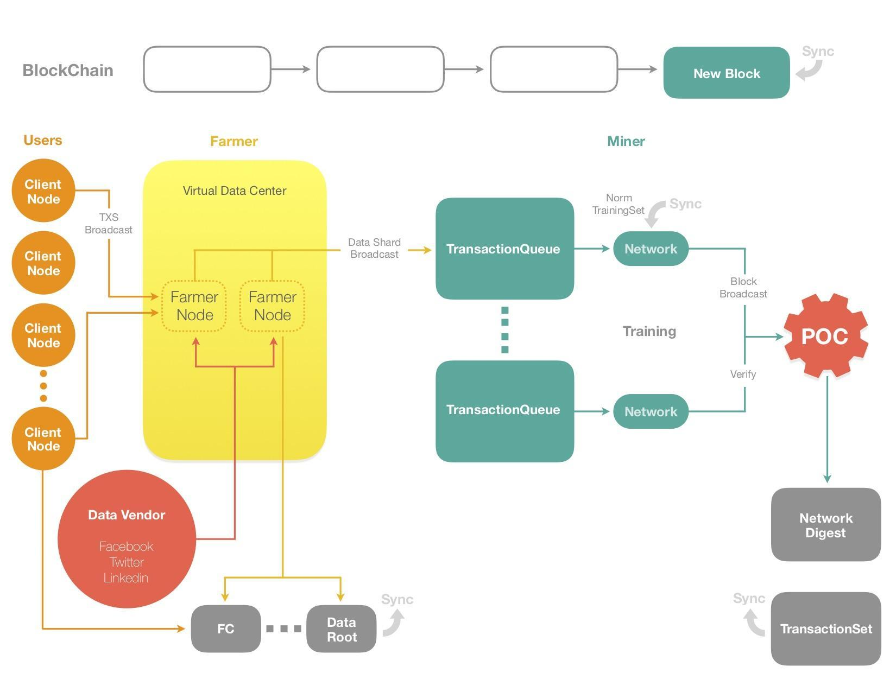

*POC Work Flow*

## **Side Chain Technology**

Genesis consists of a main chain and multiple side chains. Each chain has its own independent protocols. Interactions between the main chain and side chains are through dynamic indexing. Genesis has three embedded chains respectively represents file storage, Dapp store and node floating mechanism.

Genesis places most core content on the main chain, and extensively uses sidechain technology to share the load on the network and increase scalability. Genesis’ main chain contains the user's core information, transactions (all actions in Genesis are presented in the form of transactions such as voting and user interaction), cryptocurrency and small transactions (fault tolerance to accelerate the speed of synchronization). Genesis’ main chain is based on proven technology to guarantee the safety and stability. Side chains are key technologies for the evolution of Genesis. Users can vote to update the side chain protocol, or even migrate to a whole new side chain to achieve the evolution of the system.

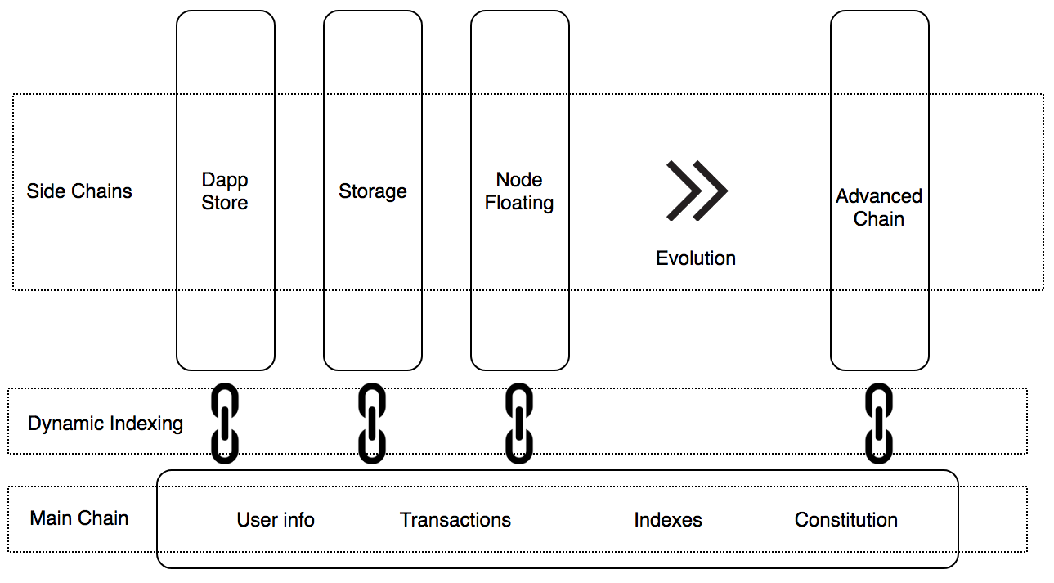

Illustration of Side Chains

### **Independent Contracts**

Each Genesis side chain has its own contacts designed to solve a particular problem. This mechanism makes it easy to handle one business a time, while maintaining a good scalability and maintainability.

### **Indexing**

The main chain contains the indexes of sides chains. Through Merkle Tree and user inputs, these chains can easily communicate.

### **File Storage**

Genesis stores most of the data on a decentralized P2P cloud drive while keeping only essential information like user’s keys to the blockchain. This enables the blockchain to record users social contents in high speed while satisfying its storage needs. A detailed technical white paper is available separately.

### **Dapp Store**

A dapp store will be built on a side chain to help developers to publish their dapps as well as for users to find and download the dapps conveniently. The dapp store has a voting mechanism to review, list and delist dapps. Dapps store have a ranking system like Reddit so good dapps are more visible to users.

### **Node Floating Mechanism**

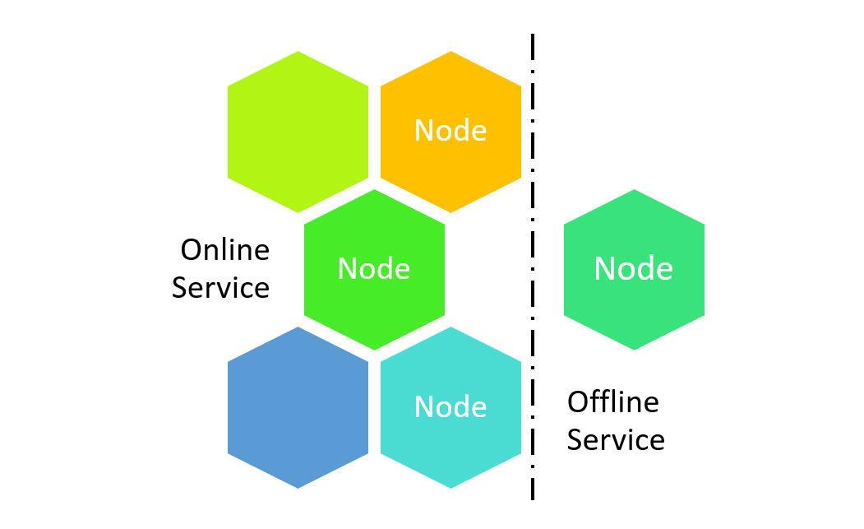In the traditional infrastructure, nodes are inseparable from the network, and there is no fault-tolerant mechanism. The decentralization of Genesis is independent of the network, nodes can exist offline. Genesis’ Node Floating mechanism makes it possible for developers to develop more complicated applications, especially those that require a combination of online services and offline services. Technical details about the Node Floating Mechanism can be found in the Genesis Node Floating Mechanism Technical Documentation.

Node Floating

*Node Segragation*

1. **Genesis Token Model**

## **Definition of Tokens**

Genesis has two currencies: Gencoin (Gc) and Genesis Money(Gm). Gencoin is the system currencies, like the ETH and Genesis Money is the circulation tokens in the Genesis network which was created when user create his group or country. Gencoin can be exchanged with circulation tokens in the system. If the user of Genesis wants to create dapp or become miner/farmer, he must own some Gencoin in his account. The user can get it from creating dapps, mining or farming.

## **Usage of Tokens**

Gencoin token holders are entitled the following rights.

* Gencoin is the system currency on Genesis. Majority of the activities on genesis requires certain amount of Gencoin, from establishing a country to creating a group.
* Gencoin is also required for running smart contract.
* Genesis Money is the circulation tokens in the Genesis network. They are created when user creates a group or country. Gencoin can be exchanged for circulation tokens in the system.
* Gencoin can be used to purchase dapps from the market.
* Gencoin can be used for business registration and API application.
* Gencoin could also be used as a threshold for a certain activity. For example, different countries may have different minimum Gencoin requirement for activities.

## **Token Sales**

The token sold during the Genesis token launch is called Gencoin (Gc), which is used as currency within the Genesis ecosystem. To raise the necessary funds for the development of Genesis, we are now selling Gencoin. Token holders would have advantageous token rights within the Genesis ecosystem. The total amount of Gencoin is 2 billion. 30% are allocated for sales to cornerstone investors, angel investors and the public investors.

* Cornerstone Investors:

Institutions only. Fund will be used for early development of Genesis.

* Angel Investors:

Fund raise is to be used for platform development as well as marketing. Schedule TBD.

* Crowd Sale:

Crowd sale date TBD. Price would be announced one day before the crowd sale, according to the price of BTC and ETH. During the crowd sale, tokens have to be claimed with two complete data segments sent from Genesis. The first data segment will be sent to user’s email and second segment will be engraved to a souvenir and sent to buyer’s home address. Both segments must be combined to obtain the Gencoin.

The remaining 70% are not for sales, reserved for the development of the Genesis platform.

* Team (15%)

15% of the generated Gencoin will be used to reward the founding team, with 4 years vesting period.

* Rewards (10%)

10% of the Gencoin would be given back to long-term investors, supporters from the community, as well as other contributors.

* Marketing and Business Development (15%)

15% of Gencoin are reserved for user acquisition, partnership development and building up developer community.

* Mining (30%)

30% are reserved as mining incentives which would be gradually released during mining.

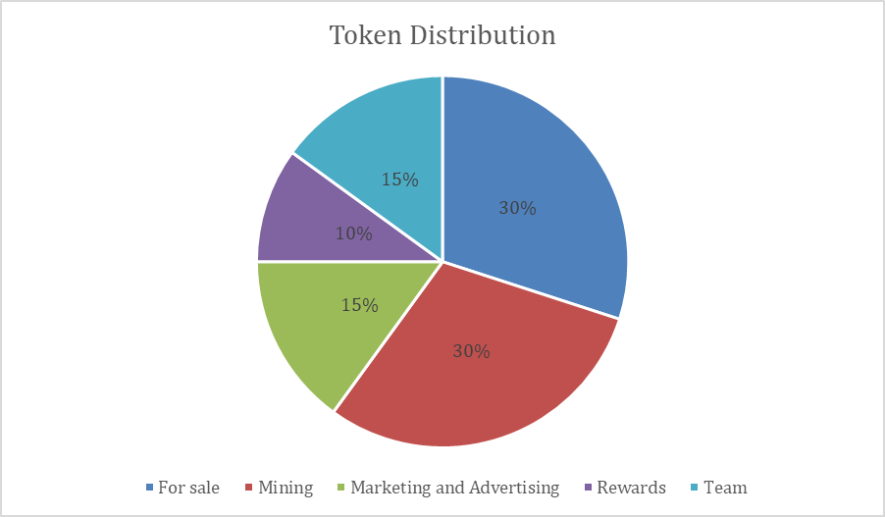

1. **Foundation**

Genesis is setting up Genesis Foundation as a non-profit organization to accelerate the adoption of blockchain technology and development of Genesis ecosystem. The Foundation accepts donations and operates in public interests relating to blockchain technology and Genesis ecosystem.

## **Governance Principles**

The principles of Genesis Foundation are to support and coordinate the efforts of the blockchain community by helping to create greater awareness of the benefits of development of the Genesis project. Through effort in awareness campaigns, Genesis Foundation promotes the use of blockchain technology and related technologies for Genesis enthusiasts, developers, regulators, technologists, practitioners and users globally.

## **Foundation Organization**

Genesis Foundation will undertake the following activities:

* Directing and supervising the development of Genesis.
* Promoting safety and harmony of the Genesis blockchain ecosystem through the adoption of best practice governance principles.
* Funding activities that will propel the development of the Genesis ecosystem and any related projects.

## **Advisory Committee**

The Advisory Committee will:

* Comprising at least 7 persons including at least one member of Genesis Foundation and at least 2 Independent Genesis advisors.
* Advising on the governance of Genesis Foundation to the members of Genesis Foundation.
* The initial term for the members of the committee will be a mix of 1 year and 2 years to ensure continuity. Thereafter, all advisors will have 2 years of appointment Genesis.

The members of Genesis Foundation will be responsible for appointing or dismissing the management Genesis team of Genesis Foundation. Genesis Foundation intends to appoint one finance lead and one legal lead to form the initial management Genesis team for the operations of the foundation. The management Genesis team will be responsible for:

* Legal and financial management Genesis.
* Supervision of the grant management Genesis process covering application management Genesis, financial tracking and reporting, and operational delivery and reporting.
* Publishing a report on the delivery of the objectives set out in the Token Sale every quarter. The audited annual financial statement Genesis will be lodged with ACRA
* Providing reports on a regular basis to the Advisory Committee

## **Budget Planning**

### **Funding Resource**

The fund for Genesis will be raised by strategic institutional investors and accredit investors under legislation. Genesis only accepts fund from people who have gone through KYC process and adhere to strict AML rules.

### **Funding Allocation**

We are raising funds denominated in Ethereum for our token launch. The coins from pre-sale will be used as following.

a. R&D: 18000 ETH 60%

b. Gencoin buy-back: 6000 ETH 20%

c. Marketing: 4500 ETH 15%

d. Reserve money: 1500 ETH 5%

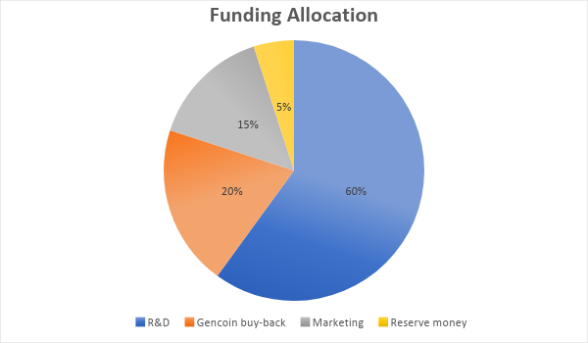

## **Road Map**

**Sprint 1:**

2018/3 Design of Genesis complete

2018/6 Demo

2018/9 Testnet

2018/12 Team dismissed after source code made public. Project is maintained by community. 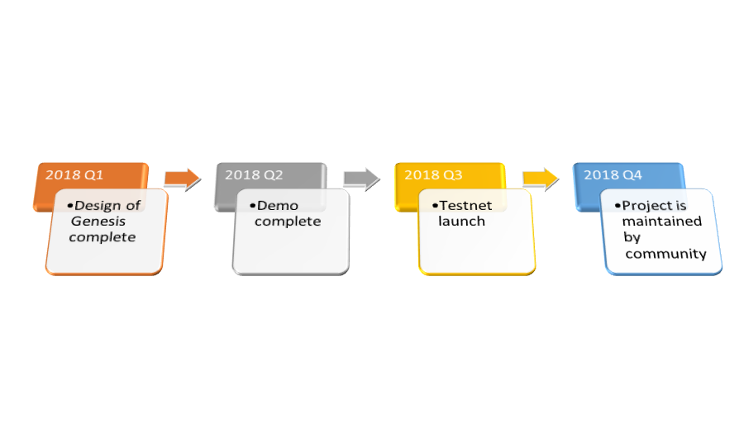

*Sprint 1*

**Sprint 2:**

2019/3 Genesis Foundation sets up dev environment

2019 6 Genesis Foundation arrange for the first upgrade of constitution.

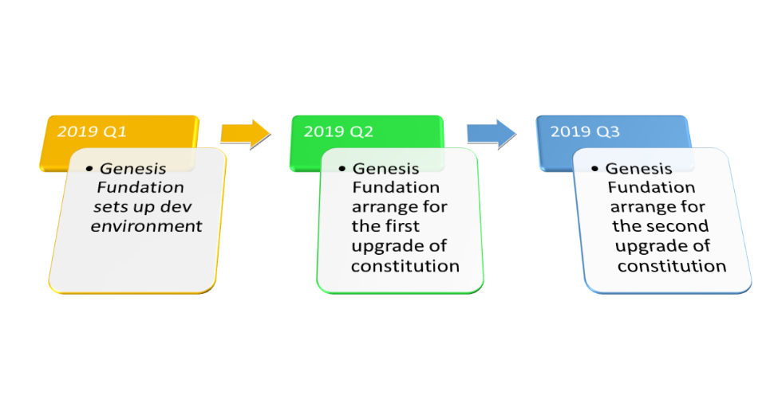2019/12 Genesis Foundation arrange for the second upgrade of constitution.

*Sprint 2*

1. **Team Members and Advisors**

Genesis team are mainly blockchain enthusiasts from the US, Japan and China. Genesis team will be dismissed, and the code will be maintained by its developer community after the project becomes open sourced. Genesis Foundation will continue to provide support and promote the community.

## **Team Members**

**Alex Li：product manager**

Alex is a serial entrepreneur. He has founded two companies in the past few years and developed many apps including American First Emergency Aid, Visual Voice Menu, Parking Ticket Pundit and others. Alex designed and operated buckete.com (e-commerce) and bacaoke.com (online functional editor). He also designed some hardware products, including VGR-Charging Cable, Zandal-Magnet Hover Sandals and Vandao-Automatic Ricecooker. Alex is full of innovative ideas. His projects and proposals had won many awards, including the Japan Asian Innovation Forum, Harvard Business School Business Plan Competition and Clinton Global Initiative. Alex graduated from Columbia University and holds two U. S. non-provisional patents. His research papers had been published in World Policy Blogs and many other leading journals.

**Tony Ma：developer**

Computer Science, M.S.

Tony graduated from Zhejiang University and obtained master’s degree in Computer Science from Carnegie Mellon University. He worked as a senior software engineer for several years in Silicon Valley before becoming the CTO of the China division of a U.S. high tech company. Tony have been working with Alex for the past few years and is responsible for the design and realization of Genesis in general.

**Gary Li：developer**

Computer Science, M.S.

Gary is a senior programmer at Alibaba and worked previously as a senior programmer in Baidu. He has rich experience in programming, and he had written a virtual machine when he was still at high school. He has extensive research and programming experience with blockchain. He had wrote an asset chain and a cryptocurrency exchange. Gary and Alex have been working together since 2014. He is responsible for the design and realization of Genesis in general.

**Vivian Yang：developer**

Computational Science, M.S.

Vivian was a programmer at EBay. Her research topics include AI, big data and machine learning. She is an early adopter of cryptocurrency. She researched on Bitcoin at Morgan Stanley in New York as early as 2015. Vivian received bachelor’s degree in Computer Science from McMaster University in Canada and master’s degree in Computational Science and Mathematics from Harvard University. Vivian is in charge of programming codes related to big data and machine learning in Genesis.

**Whizkid Deng: scientist**

Ph.D in Mathematics

Yongzhe received his Ph.D in Mathematics from the Chinese University of Hong Kong. He obtained bachelor’s degree from Zhejiang University and won the first prize in Mathematical Modeling competition in China and the U.S. Yongzhe had been researching on cryptology for many years. He is responsible for designing the privacy protection system and encryption method in Genesis.

**Kelvin Zhu: scientist**

Ph.D in Computer Science

Fengyuan Zhu received his Ph.D in Computer Science from the Chinese University of Hong Kong. Kelvin specialized in AI and machine learning research. His research papers have been published by many leading magazines and presented in top conferences. Fengyuan had participated in the design of POC mechanism for Genesis.

**Chen Han：scientist**

Ph.D Transportation and System Engineering

Chen Han obtained bachelor’s degree from Tsinghua University and subsequently completed his Ph.D at Berkeley in 3 years. Chen Han is currently working at eBay. His research focuses on big data and machine learning.

**Jerry Zhao：scientist**

MS. in Electrical Engineering

Jinwei graduated from Tsinghua University. He is a senior researcher at Tencent. Jinwei has over 10 years of research experience in AI, deep learning and machine learning. Jinwei has participated in the design of POC mechanism for Genesis.

**Hua Lei：community support**

Hua Lei is the co-founder of Talenta. She has helped many projects to successfully launch ICOs, including TenX, Zillqa, THEKEY and many others. Hua Lei is in charge of fundraising and marketing operations in Genesis.

**Aaron Shen：community support**

Aaron obtained Ph.D in Computer Science. He has been an active participant in the cryptocurrency community. He co-founded Future Angel Foundation and has led the investment of many blockchain projects. He has also developed excellent connections in the cryptocurrency and blockchain community since 2014 when he started researching on and participating in blockchain projects.

## **Advisors**

**Michael Tang**

Michael graduated from Harvard Business School. He has been a seasoned trader and a high-ranking Director at Wall Street for decades. He is also a writer and has published many books in English.

**Steve Peng**

Steve graduated from Harvard Business School. He has been a high-ranking Director of many financial institutions in Wall Street and London. Currently Steve manages a Venture Capital in Shanghai.

**Raymond Tan**

Raymond is the Director of Crypto currency and Blockchain Application Foundation . He graduated from Waseda University in Japan. Raymond has participated in the development and management of many large-scale commercial IT projects across industries like manufacturing, education, finance and telecommunication. He has rich experience in team management and project management. Raymond has been researching on blockchain applications and cryptocurrency since 2014 and he has developed rich connections in the industry.

1. **Originality Statement**

The POC（Proof of Comprehension）mechanism of Genesis is 100% original idea and design by the Genesis team. We have filed for global IP patents. Any unauthorized use including copying, plagiarizing, modification and quotation of any part or format considered infringement. We reserve our rights to take legal action to its full extent.

1. **Disclaimer**

This document does not constitute an offer or solicitation to sell shares, debenture or collective investment scheme in Genesis platform, or any relevant or associated company. Any such offer or solicitation would be made only by means of a confidential offering memorandum, which this is not, and in accordance with the terms of all applicable securities and other laws. None of the information or analyses presented are in-tended to form the basis for any investment decision, and no specific recommendations are intended. Accordingly, this document does not constitute investment advice, counsel, or solicitation for investment in any security. This document does not constitute or form part of, and should not be construed as, any offer for the sale or subscription of, or any invitation to offer to buy or subscribe for, any securities.

This document doesn’t involve any investment suggestions on forms of securities, investment intentions or abetment. It neither includes nor understands any practices of trading or trading invitations. It is neither a contract nor a promise of any form.

Genesis notes that potential users are fully aware of the platform’s risks. The investor recognizes and is willing to take risks and all consequences the moment he invests in the platform

Genesis expressly disclaims any and all responsibility for any direct or consequential loss or damage of any kind whatsoever arising directly or indirectly from: (1) Any mistakes, errors or inaccuracy in any such information or any behaviors thereof. (2) Any losses incurred by personal trading of blockchain assets or any behaviors thereof. (3) any action resulting from such information.

Genesis is not an investment. We can’t guarantee that Genesis is bound to appreciate. Under certain circumstances, there exist possibilities of GENESIS depreciation. Those who fail to use the Genesis in an appropriate way will forfeit right of using the currency or even lose their currencies.

Genesis is neither an ownership or control right. Possession of Genesis doesn’t equal ownership of Genesis or Genesis application. Genesis doesn't entitle anyone to participating in, controlling or deciding issues regarding Genesis and its application.

## **Risk Warning**

The Genesis expressly disclaims any liabilities whatsoever to the purchaser, and shall not be liable to the purchaser for any loss, damage or delay caused by, arising from, or in respect of the following:

### **Risks in respect of the Ethereum Protocol**

Any failure, destruction, dysfunction of the Ethereum protocol will beyond the control of the control of the GENESIS team and may have a material adverse effect on the GENESIS tokens, which is being established upon Ethereum protocol;

### **Risk in respect of delivery**

Due to the nature of the blockchain technology which is diffusely adopted for cryptocurrencies, include but not limit to smart contract system, the purchaser may not receive the tokens on the same day which purchaser finish the payment process of GENESIS tokens. By offering to purchase the tokens from GENESIS platform, the purchaser agrees that it is purchaser’s responsibility for implementing reasonable measurements for securing the receiving wallet, vault or other storage mechanism you use to receive and possess the GENESIS tokens.

### **Risks in respect of security failure**

GENESIS platform and/or GENESIS tokens remain susceptible to vindictive cyberattacks by autonomous nature person, legal person, software, illegal cyber activities and organized crime. The internal security of the GENESIS protocol’s core infrastructure might also be debilitated under the security failure.

### **Risks in respect of regulatory impacts**

The regulatory status of cryptographic token is unclear or undefined in many jurisdictions. In the event that any legislative authority or administrative authority publishes or amend the laws, regulations and guidance might have negatively impact on the GENESIS tokens.